METROPOLITAN UNITED CHURCH INFORMATION PACKAGE
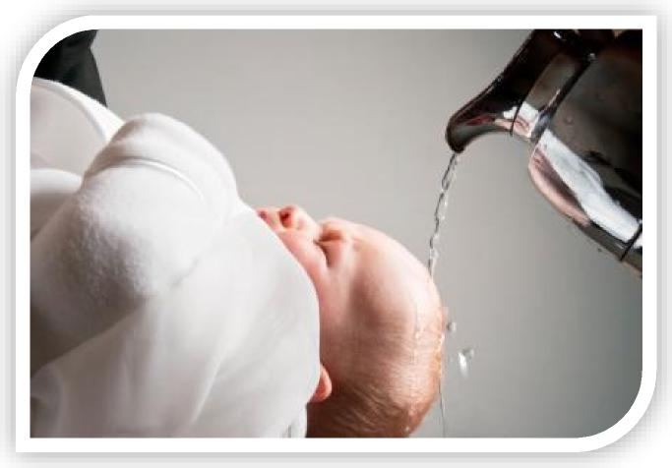
Baptism or Blessing

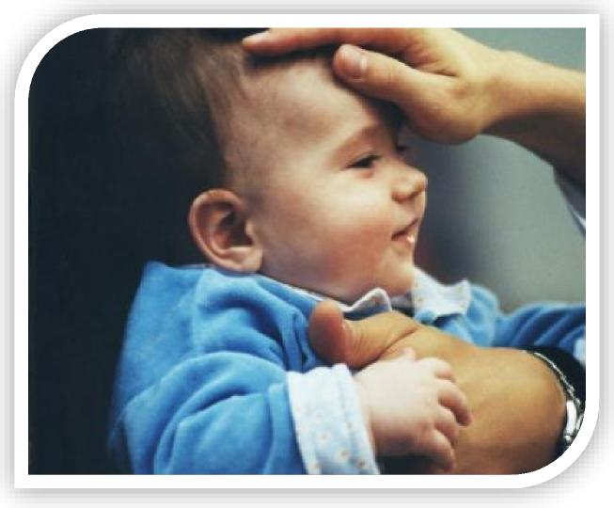

Information for Parents on Baptism or Blessing for their Children
Metropolitan United Church
The Meaning of Baptizing a Child
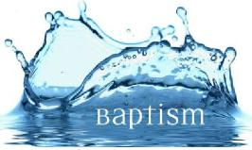
Baptism, whatever the age of the person being baptized, is the sole rite of initiation into full membership in the Christian community, the Body of Christ. The baptism service celebrates the graceful initiative of God in calling and claiming us, and the faithful response of the people as individuals and as a community. Baptism is a Sacrament of the Church, instituted by Christ. By Baptism we enter the Church, where we are nourished in faith and life.
The Christian Scriptures do not specifically say that children were baptized. They do suggest, however, that whole households were baptized together, and we assume children were included in that (Acts 16:15; 1Corinthians 1:16). The New Testament was written during a time when the Church was spreading rapidly, and so, at that time, the Baptism of adults was the most important thing. In the Baptism of anyone, the personal faith of the one being baptized is important.
The water is symbolic of birth into a new kind of life and a new kind of community. The gift of the Holy Spirit which accompanies Baptism gives power to live this new life. The new life is understood as a life of union with Christ and with Christ’s people.
New Testament writers speak of that experience in different metaphors; Paul speaks of participation in the death and resurrection of Jesus; John talks of new birth; still others talk of liberation from bondage and of the freedom of a new humanity;
This gift of God in Jesus Christ, celebrated and claimed in Baptism, is the beginning of enduring participation in the journey of God’s people towards God’s New Creation.

The Meaning of Blessing a Child
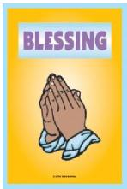
"People were bringing little children to him in order that he might touch them; and the disciples spoke sternly to them. ¹⁴ But when Jesus saw this, he was indignant and said to them, “Let the little children come to me; do not stop them; for it is to such as these that the kingdom of God belongs. ¹⁵ Truly I tell you, whoever does not receive the kingdom of God as a little child will never enter it.” ¹⁶ And he took them up in his arms, laid his hands on them, and blessed them." ~Mark 10:13-17
For families who are not, and do not wish to become, active members of Metropolitan United Church at this time, Metropolitan United offers a Blessing for their child.
The purpose of a Blessing is to celebrate the birth of a child and confirm God's unconditional love and blessing for this child. While Baptism takes place during worship, Blessings can take place either during worship or in a more private setting.
The Blessing option preserves the integrity of the parents and the sacrament of Baptism (with all its vows and promises connected to membership).
Some Questions and Answers

 DO I HAVE TO BE A MEMBER OF METROPOLITAN UNITED CHURCH (MUC) TO HAVE A CHILD BAPTIZED?
Yes, a requirement for having a child baptized is that at least one of the parents must be a member in good standing at Metropolitan United Church.
The United Church of Canada Manual states:
A person becomes a full member through one of the following ways:
- adult baptism and profession of faith;
- confirmation, if the person was baptized as a child and has now reached the age of understanding;
- reaffirmation of Christian faith, if the person has already been baptized and made a profession of faith at an earlier time;
- through a certificate of transfer of membership in good standing from another congregation or church; or
- if they cannot get a certificate of transfer of membership from another church, they may transfer their membership if the governing body is satisfied that they:
    - have been baptized;
    - became full members of their church after they made a profession of Christian faith;
    - are of good Christian character; and
    - have valid reasons for transferring to the United Church
 WHAT DOES IT MEAN TO BE A MEMBER "IN GOOD STANDING" AT MUC?
Baptism is about church membership. Membership is a core identity and is a journey of discipleship. Like the disciples in the Gospels themselves, none of us is perfect or ideal. We are all at different places of understanding, maturity and commitment.
Regardless of where we find ourselves on our faith journey, members "in good standing" seek to:
- Grow their belief in God or the Divine and that Jesus of Nazareth plays a central role in their faith journey.
- Actively seek, as they are able, to deepen their faith through personal and collective study; through prayer and reading scripture; through pursuing answers to questions and obstacles to faith.
- Attend Sunday worship as often as they are able and help build up the community of healing care
- Discern their talents and gifts and answer their ‘call”; do their part in the mission and ministry of God, in Christ.
- Support the mission and ministry of the church with their time, talents, and treasure as they are able.

 DO YOU HAVE PRIVATE BAPTISMAL/BLESSING SERVICES?
Because Baptism is the Sacrament by which a person becomes part of the Christian community, it is to be celebrated at the regular Sunday service, with the congregation present. However, Blessings can take place either during worship or in a more private setting.
 IS THERE A FEE FOR HAVING A CHILD BAPTIZED/BLESSED?
No. Sometimes parents or their families may want to make a donation to the church on this special occasion.
 WHAT IF I LIVE OUT OF TOWN, BUT WANT TO HAVE MY CHILD BAPTIZED/BLESSED AT MUC BECAUSE THIS IS MY “FAMILY CHURCH”?
We would be happy to baptize your child on behalf of the congregation where you presently are a member. Blessings can be done for anyone regardless of where they reside.
 WHAT ABOUT GODPARENTS FOR BAPTISMS?
Godparents are welcome. If you have Godparents, we would be happy to incorporate them into the service. In the United Church we believe that the congregation normally assumes that role.
 WHAT SHOULD WE DO NOW?
Once you have thoroughly read this material, take the time to think and talk about your own relationship with the Church.

Decide whether you and your child are ready for membership and discipleship in the church. If you are ready to make this commitment, apply for Baptism. However, if you are not ready for this step at this time, the Blessing of your child should be what is requested.
If you desire to continue with the baptism/blessing, contact the church office and book an appointment to see one of our ministers.
Should I Choose Baptism or Blessing For My Child?
 I WANT TO GIVE THANKS TO GOD FOR MY CHILD’S BIRTH.
Blessing your child is a great way to give thanks for their birth. This is done as part of a Blessing or Baptism. Baptism is about much more than this however. It is about membership in the church.
 I WANT MY CHILD TO GO TO SUNDAY SCHOOL.
Neither baptism nor blessing is a condition for attending Sunday School. No child is ever turned away.
 I WANT TO PROTECT MY CHILD FROM GOING TO HELL IF HE/SHE SHOULD DIE.
Many people seek Baptism for their child for this reason. We do not believe, in the United Church if Canada, that God would condemn children to hell because they are not baptized. Baptism is about church membership and choosing to raise your child in the Christian faith.
I WANT MY CHILD TO BE ABLE TO BE MARRIED IN THIS CHURCH
Whether your child eventually wishes to marry as a Christian or not will be their own decision when the time comes. We do not require baptismal certificates for marriage.
 I WANT TO SAVE MY CHILD THE EMBARRASSMENT OF BEING BAPTIZED WHEN THEY ARE OLDER OR GROWN.
Adult baptism is not only the original form of Christian Baptism, it is a profoundly significant experience for those who decide on their own to be members of the church. We baptize people of all ages.

 I WANT MY CHILD BAPTIZED JUST BECAUSE IT IS A TRADITION OF OUR FAMILY.
The tradition of Baptism without any commitment to Christ and the Church is a total misunderstanding of Baptism. Perhaps a Blessing would be a better option for your family.
 MY CHILD'S GRANDPARENTS WOULD BE UPSET IF THEY WERE NOT BAPTIZED.
In most cases, it is you, their parents, and not their grandparents, who must give them a Christian upbringing if they are baptized. No matter what others think or feel, the decision must be yours. Again, if this is the reason you are seeking Baptism, we would suggest that Blessing would be the better option.
 I WANT TO GIVE MY CHILD A CHRISTIAN NAME AT THE BAPTISM
In other faith traditions, this is called Christening, and is not a part of our United Church tradition.
Vows & Liturgy used at Baptisms
Statement of Purpose: The sacrament of baptism is the one right of initiation into membership in the Christian Church. We are united with Christ, united with one another and the Christian community of every time and place; we are called as Disciples of Christ to Christ’s ministry of love, peace, and justice, and strengthened by the Holy Spirit for the work of the church in the world. During this sacrament we all recommit ourselves to this calling.
Promises of Parents: Will you accept the responsibility of acting and speaking on your child’s behalf? Will you endeavor to show your child the Christian life and to grow with your child in faith? “I will, God being my helper.”
Will you join with this community of faith to celebrate God’s presence, live with respect in creation, and love and serve others? “I will, God being my helper.”

If needed ~ Promises of Godparents
Will you grow in faith with this child, trusting that, “you are not alone, and that you live in God’s world”? I will, God being my helper.
Profession of Faith: Do you believe in God and in God’s unconditional love as revealed in Jesus Christ? “Yes, I do!”
Will you seek justice and resist evil? “I will, by the grace of God.”
Will you follow Jesus in both your words and deeds? “Yes, with God being my helper.”
Congregational Commitment: By the grace of God, will you, the members of the Metropolitan United Church, commit to support and nurture (insert names), within a community which worships God, resists evil and seeks justice? "We will, God being our helper"
Prayer of Thanksgiving and the Pouring of Water: Gracious and Holy God, we bless you for the gift of life, and, within it, the gift of water. Over its unshaped promise your Spirit hovered at creation. By water, comes the growth of the earth. Through water, you led the children of Israel to freedom. In the waters of the Jordan your child Jesus was baptized. Now may your Spirit be upon us and what we do. May this water be a sign of new life in Christ for all, in whose name we pray. Amen.
The Act of Baptism: What is name of your child? (Insert name), I baptize you, in the name of the Father, and of the Son, and of the Holy Spirit. Amen.
Marking with the Sign of the Cross with Water: (Insert name), with the sign of the cross, you are marked as Christ’s forever. Amen.
Blessing: (Insert name), may the Holy Spirit guide and strengthen you today and always. Amen
Congregational Welcome and Walkabout
Choral Blessing (Choir)

Liturgy used at Blessings
Jesus gathered children to him and blessed them.
"People were bringing little children to him in order that he might touch them; and the disciples spoke sternly to them. ¹⁴ But when Jesus saw this, he was indignant and said to them, “Let the little children come to me; do not stop them; for it is to such as these that the kingdom of God belongs. ¹⁵ Truly I tell you, whoever does not receive the kingdom of God as a little child will never enter it.” ¹⁶ And he took them up in his arms, laid his hands on them, and blessed them." ~Mark 10:13-17
Throughout the Bible, children are loved and called by God. Children are a blessing to our present world and represent hope for the future. By bringing children into a broken world, parents live out an extraordinary faith and hope in God. As we bless this child, we remember that God's grace arrives before anything we do, think or imagine. Today we recognize within this community of faith what God has already done. God's love and grace has poured out upon this child since birth and shall endure forever.
Presentation of the Child: What is the name of this child?
Laying on of Hands: People are invited to lay their hand on the child as the following blessing is said: (Insert name), you are blessed by God. May God's joy always be in your heart. May God's love surround your living. May you love kindness, seek justice and walk humbly with God. May God's presence strengthen you day and night.
Marking with the Sign of the Cross with Oil: (Insert name), with the sign of the cross, you are blessed. Amen.
Prayer: Eternal God, enfold (insert name) and his/her family with your grace. May their home be a place of your presence, your peace, your love, your forgiveness and your freedom. Amen
Choral Blessing (Choir)

